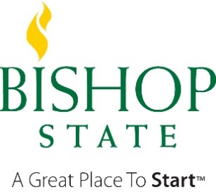
Office of Financial Aid
Asset Clarification Request
A Member of the Alabama Community College System

Your 2020/2021 Free Application for Federal Student Aid (FAFSA) was selected for review in a process called verification. Before awarding Federal Student Aid, we will ask you to confirm the information you reported on your FAFSA. To verify that you provided correct information, we will compare your FAFSA with the information on this institutional verification document and with any other required documents. If there are differences, your FAFSA information may need to be corrected.

Please complete and sign this Asset Clarification document indicating the value of all assets as of the date the student completed the 2020/2021 FAFSA. Asset information was left blank on the FAFSA, but is required because the student does not qualify for the simplified needs analysis.

- Student’s Information

___________________________________________________ _A______________________________
Student’s Last Name First Name M.I. Bishop ID Number

___________________________________________________ ________________________________
Student’s Street Address (include apt. no.) City State Zip Student’s Date of Birth and Last 4 Digits of SSN

______________________________ _____________________________@bishop.edu
Student’s Phone Number (include area code) Bishop Email

This form must be completed in full in order for our office to complete the verification process for 2020/2021. If you do not have any dollar amount to report, please use zero, “0.” Blank or incomplete forms will not be processed.

- Dependent Students – please complete the information for both you and your parents.
- Independent Students – please complete the information for both you and your spouse if you are married

Asset Questions | STUDENT | PARENT(S)
As of the date the 2020/2021 FFSA was completed, what was your total balance for cash, savings, and checking accounts? | $ | $
As of the date the 2020/2021 FFSA was completed, what was the net worth of your investments, including real estate? Net worth means value minus debt. DO NOT include the home you live in. | $ | $
As of the date the 2020/2021 FFSA was completed, what was the net worth of your business and/or investment farms? DO NOT include a family far or family business with 100 or fewer full-time or full-time equivalent employees. | $ | $

- Certification and Signature:

WARNING: If you purposely give false or misleading information you may be fined, sentenced to jail, and/or removed from school.

Each person signing below certifies that all of the information reported is complete and correct. The student and one parent (if student is dependent) whose information was reported on the FAFSA must sign and date.

If parent signature is not available due to Covid-19, please provide a statement on the signature line.

____________________________________ ___________________
Student’s Signature Date
no electronic signature, must be original

____________________________________ ___________________
Parent’s Signature (dependent student’s only) Date
no electronic signature, must be original

